Name: | ___________________________________________________ |  | Date: ___________
 | Year 10  (Pre stage 2)  In Class Investigation  Transforming Quadratics |  | 23  = %
Total Time: | 55 minutes | Penalties (only deducted once in the whole assessment):   Rounding - Incorrect/inappropriate (-1)   Notation – incorrect/missing (-1)   Units - Incorrect/missing (-1)
Weighting: | ____% of the year.
Equipment: | CAS calculator
Important Information:
This investigation will be completed under test conditions. Answers should be rounded appropriately. All working should be shown in the space provided. Solutions without working may not be awarded full marks. Please take the marks for each question into account when answering the question.

1. | [3 marks: 1, 1, 1]
i)  ii)  iii) | In the graph below the curves B, C and D are all of the same shape as the curve A. If the curve A has equation  y = x². Write down the equations of curves B, C and D.  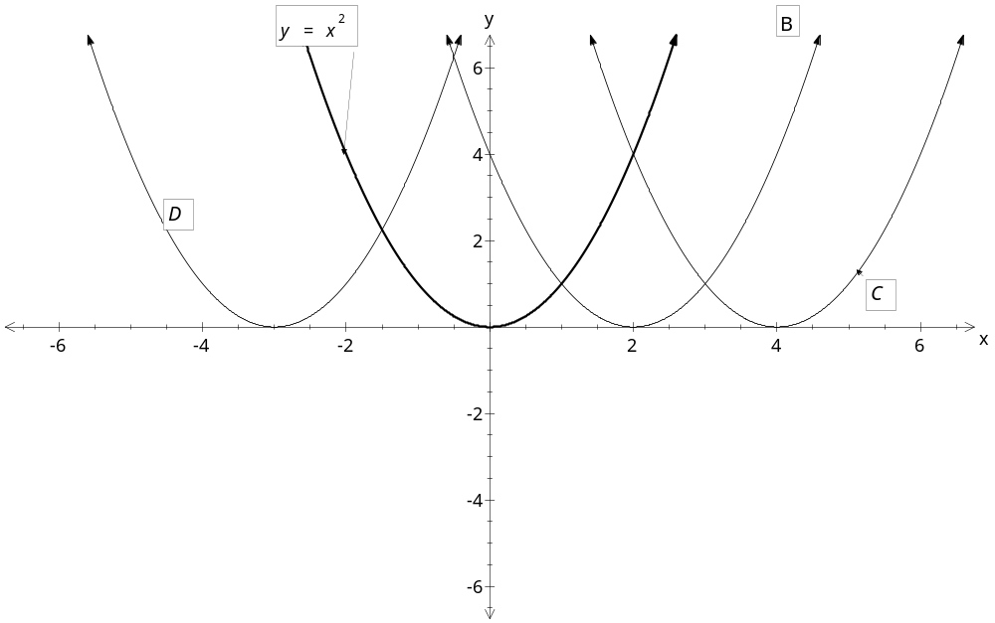  Equation of B __________________________  Equation of C __________________________  Equation of D __________________________
2. | [9 marks: 1,1,1,2,2,2 ]
 | In the graphs below the curves E, F , G, H, I and J are all of the same shave as the y = x² curve. Write down the equations of the curves E, F, G, H, I and J.
 | 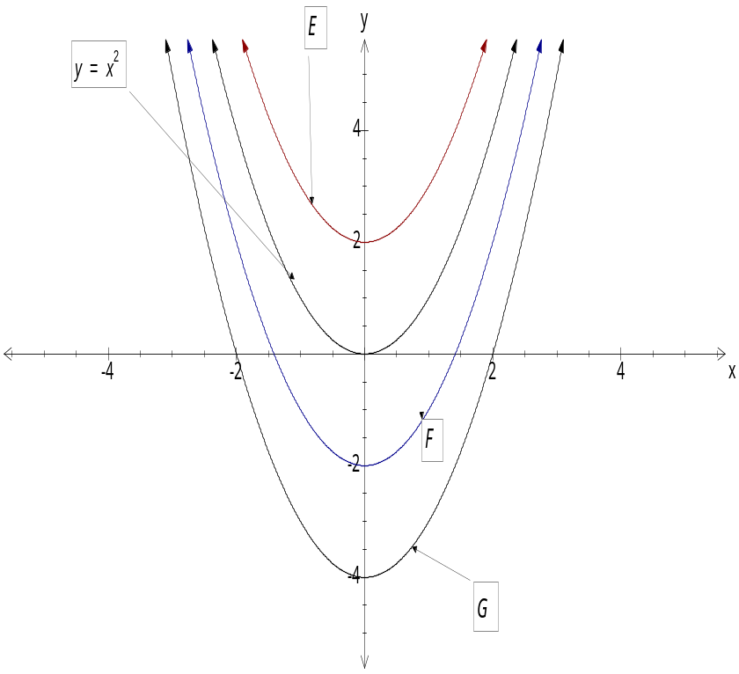  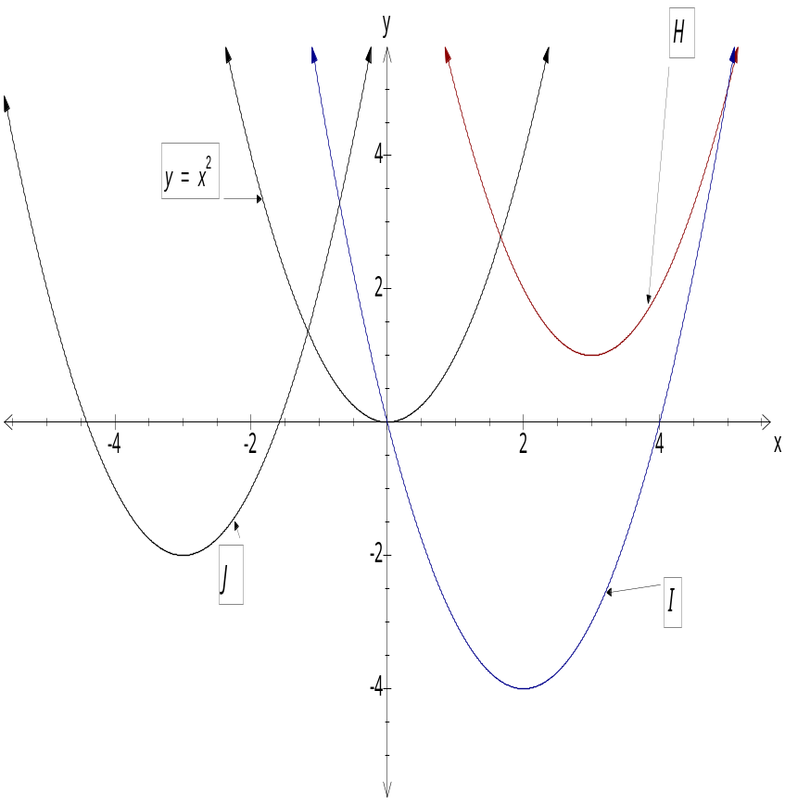 |  | Equation of curve E  ________________________________  Equation of curve F  _________________________________  Equation of curve G  _________________________________  Equation of curve H  __________________________________  Equation of curve I  __________________________________  Equation of curve J  __________________________________
3. | [ 3 marks: ½, ½, ½, ½, ½, ½ ]
 | The diagram below shows the graphs of six quadratic functions labelled K, L, M, N, O and P. Match each of the following equations with one of the given graphs
a) | y = - x² | 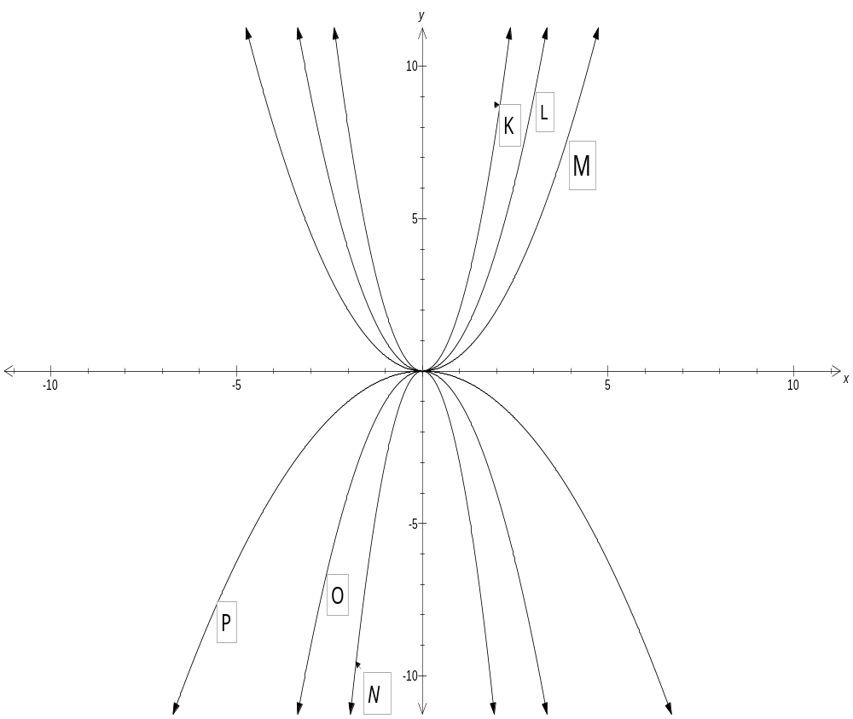
b) | y = ½ x²
c) | y = -3x²
d) | y = 2x²
e) | y = - ¼ x²
f) | y = x²
4. | [3 marks: 1, 1, 1]
 | Describe the following transformation in your own words:
a) | 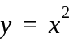 → 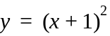
b) | → 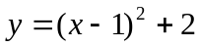
c) | → y = – 0.5x²
5. | [ 5 marks: 2, 3 ]
The following graph shows a quadratic curve with function y = 4(x – 3) ² + 3.

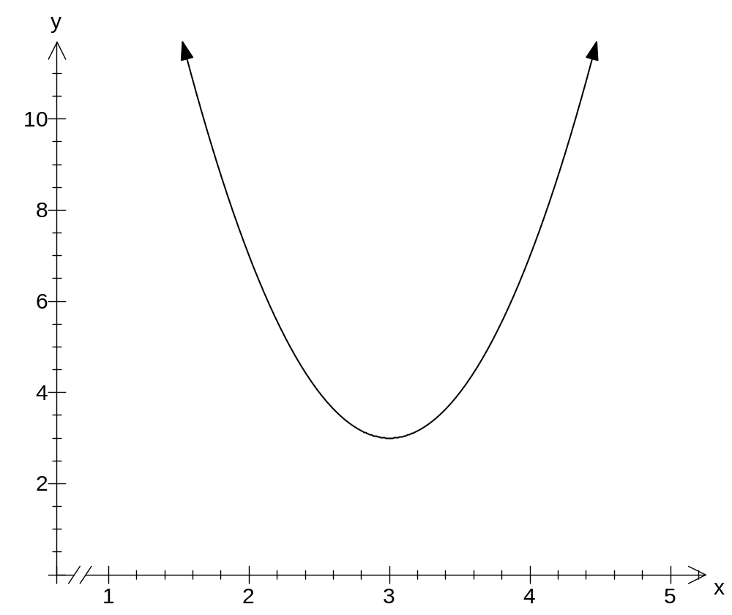

a) | Translate the parabola 3 units up and 1 unit left in the same graph.
b) | Write the equation of a new translated parabola.

